NAAN MUDHALVAN ARTS INTERNSHIP PROGRAM 2026

PYTHON FOR DATA ANALYTICS PROJECT SUBMISSION TEMPLATE

STUDENT NAME: E. SANTHIYA
YEAR:
COLLEGE CODE:137
COLLEGE NAME: Government Arts and Science College for Women, Alangulam
DEPARTMENT: B Sc Computer Science
SEMESTER: V
ROLL NO:24081371802112144
NMID:
TITLE: Food delivery sales and customer insights
GITHUB LINK:
DATE:

ABSTRACT
This project analyzes food delivery sales data to understand customer ordering patterns and popular food items. The dataset was cleaned and analyzed using Python libraries such as Pandas and Matplotlib. Various analyses were performed to identify peak order times, popular dishes, and location-wise order distribution. Visualizations such as bar charts, line charts, and pie charts were created to represent the insights. The results help food delivery businesses improve customer service and increase sales.
PROBLEM STATEMENT

Food delivery companies receive thousands of orders daily. Understanding customer preferences and ordering behavior is important for improving business performance. This project analyzes food delivery data to identify popular food items, peak ordering times, and location-based trends.

OBJECTIVES
    - Analyze food delivery sales data.
    - Identify customer ordering patterns.
    - Find the most popular food items.
    - Determine peak order times.
    - Visualize business insights using charts.

PROJECT SCOPE

This project focuses on analyzing food delivery order data using Python and Google Colab. It helps businesses understand customer preferences and improve decision-making through data-driven insights.

TECHNOLOGIES USED

Programming Language: Python

Development Environment: Google Colab

Libraries:

Pandas

Matplotlib

Dataset Type: CSV

APPLICATIO0N FLOW
- Load Dataset
- Data Cleaning
- Data Analysis
- Find Popular Foods
- Identify Peak Order Times
- Generate Charts
- Obtain Business Insights

KEY PYTHON DATA ANALYTICS CONCEPTS USED
- Data Handling
- Data Cleaning
- Exploratory Data Analysis (EDA)
- Visualization

EXPECTED OUTPUT

Dataset Preview

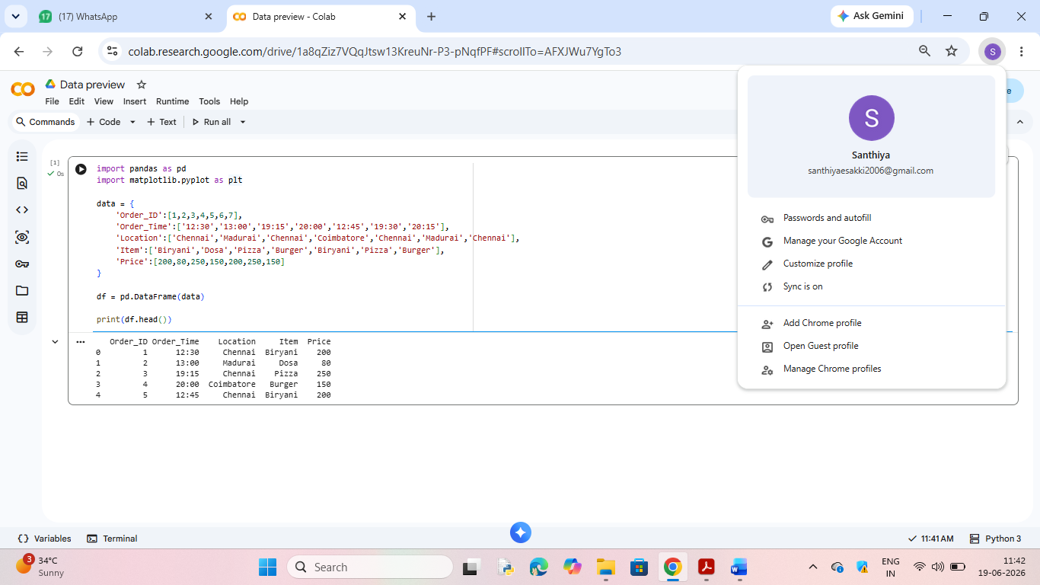

Popular Food Items Chart
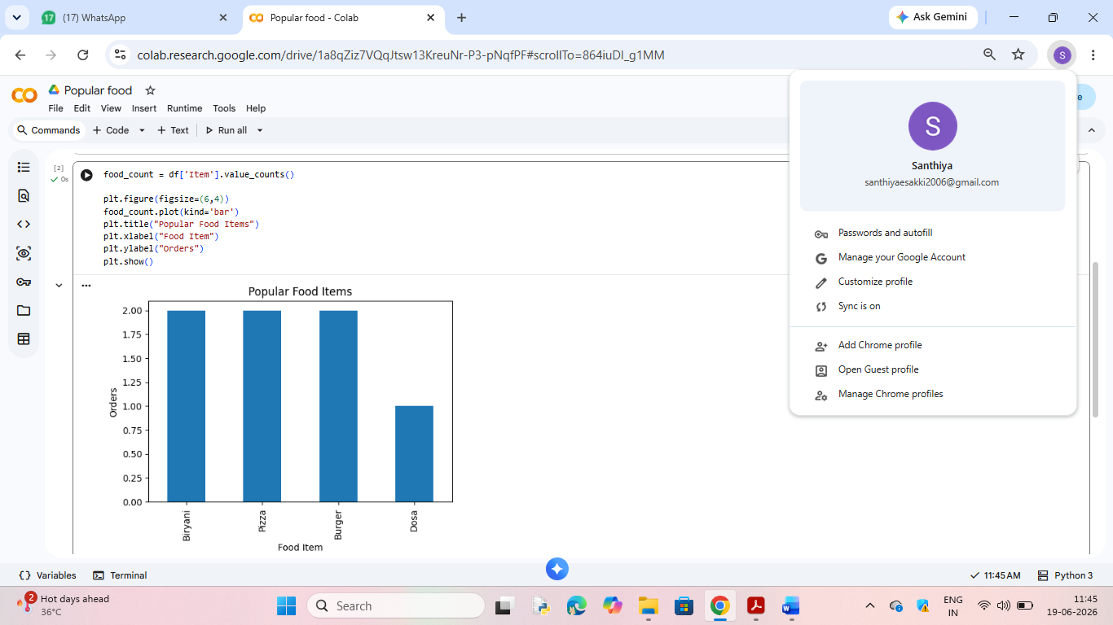

Peak Order Time Chart

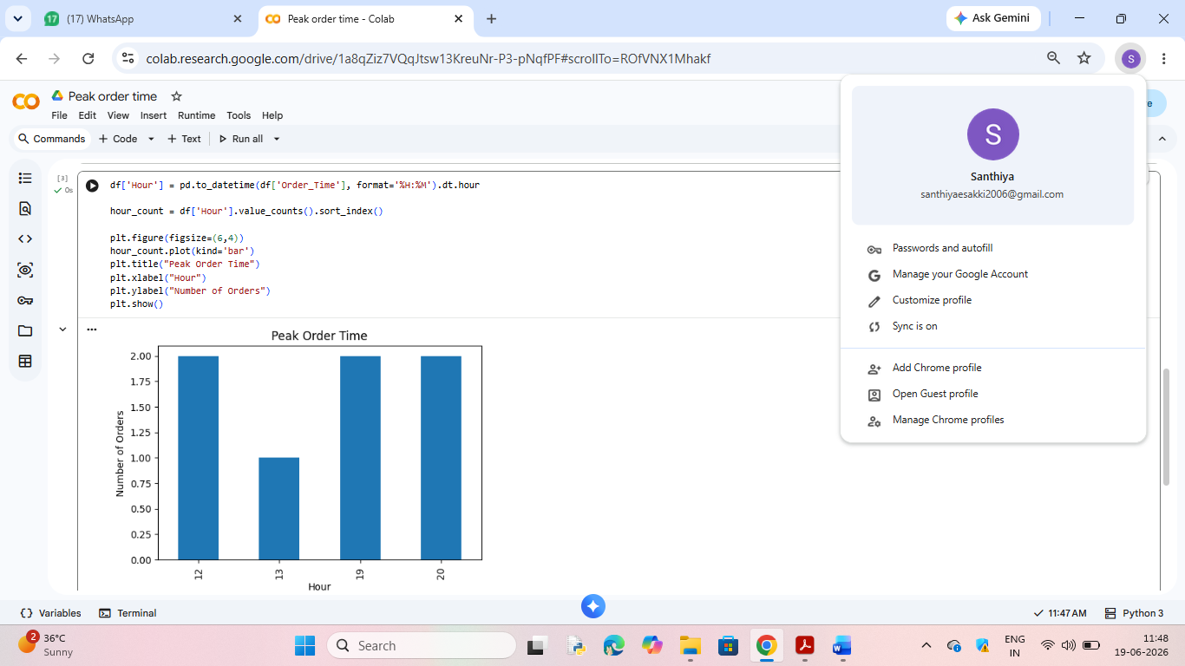

Location-wise Orders Pie Chart
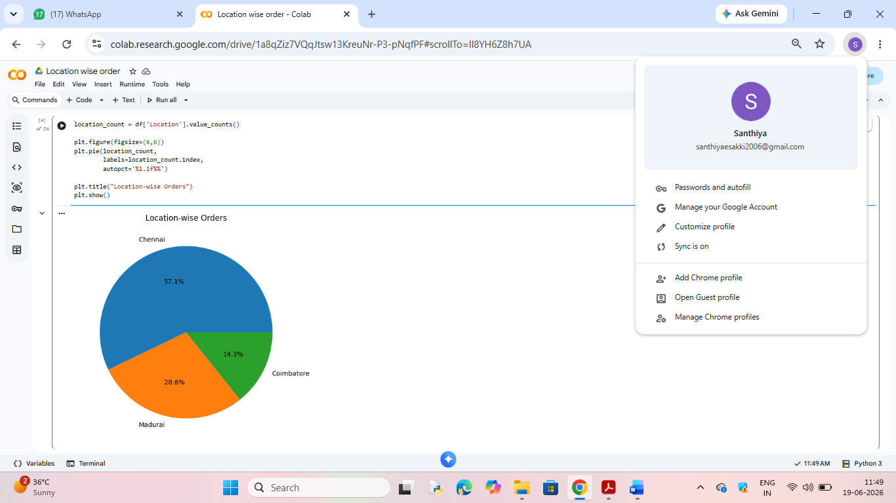

Business Insights

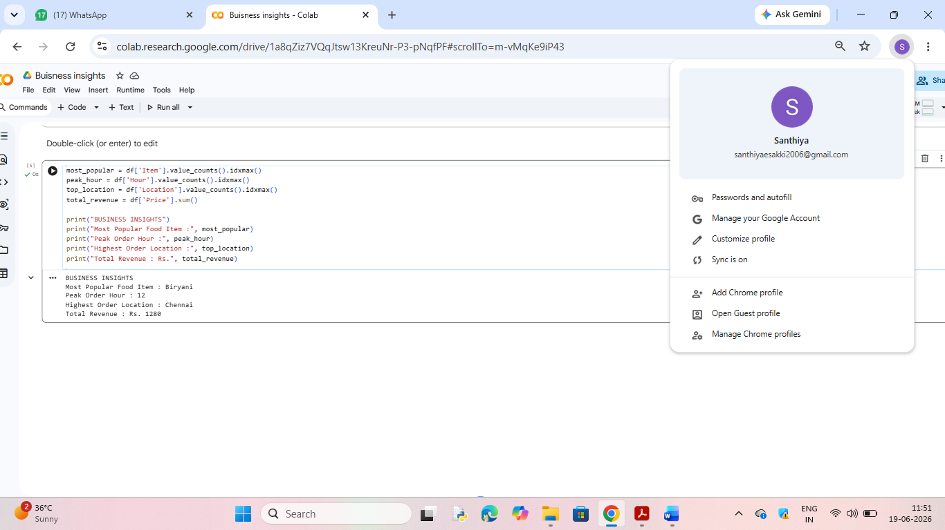

CHALLENGES FACED

- Handling missing data
- Formatting time values
- Creating meaningful visualizations

LEARNING OUTCOMES

Learned data analysis using Pandas.

Learned data visualization using Matplotlib.

Improved data cleaning skills.

Understood customer behaviour analysis.

CONCLUSION
The Food Delivery Sales & Customer Insights project successfully analyzed customer ordering patterns and food preferences. The insights obtained from the analysis can help businesses improve customer satisfaction, optimize delivery operations, and increase sales.

